**ASSIGNMENT-3**

**MODULE 7**

**DYNAMODB**

**DONE BY**

**RANJITH KUMAR**

**TASKS:**

**1. Create a DynamoDB table with partition key as ID.**

**2. Add 5 items to the DynamoDB table.**

**3. Take backup and delete the table.**

STEP 1 : Open DynamoDB from aws services

STEP 2 : Then Tables > Create table

STEP 3: Give the table name and partion key to identify items in a table

STEP 4 : Table is created

STEP 5 : Select the table > Actions > Create iteams to add items in the table

STEP 6 : Add items of our needs

STEP 7 : Now select backup > Create backup. Create a backup of the table

STEP 8 : Create a backup

STEP 9 : Now select table and delete the table

STEP 10 : Select backups > Restore .

STEP 11 : Deleted table has been restored

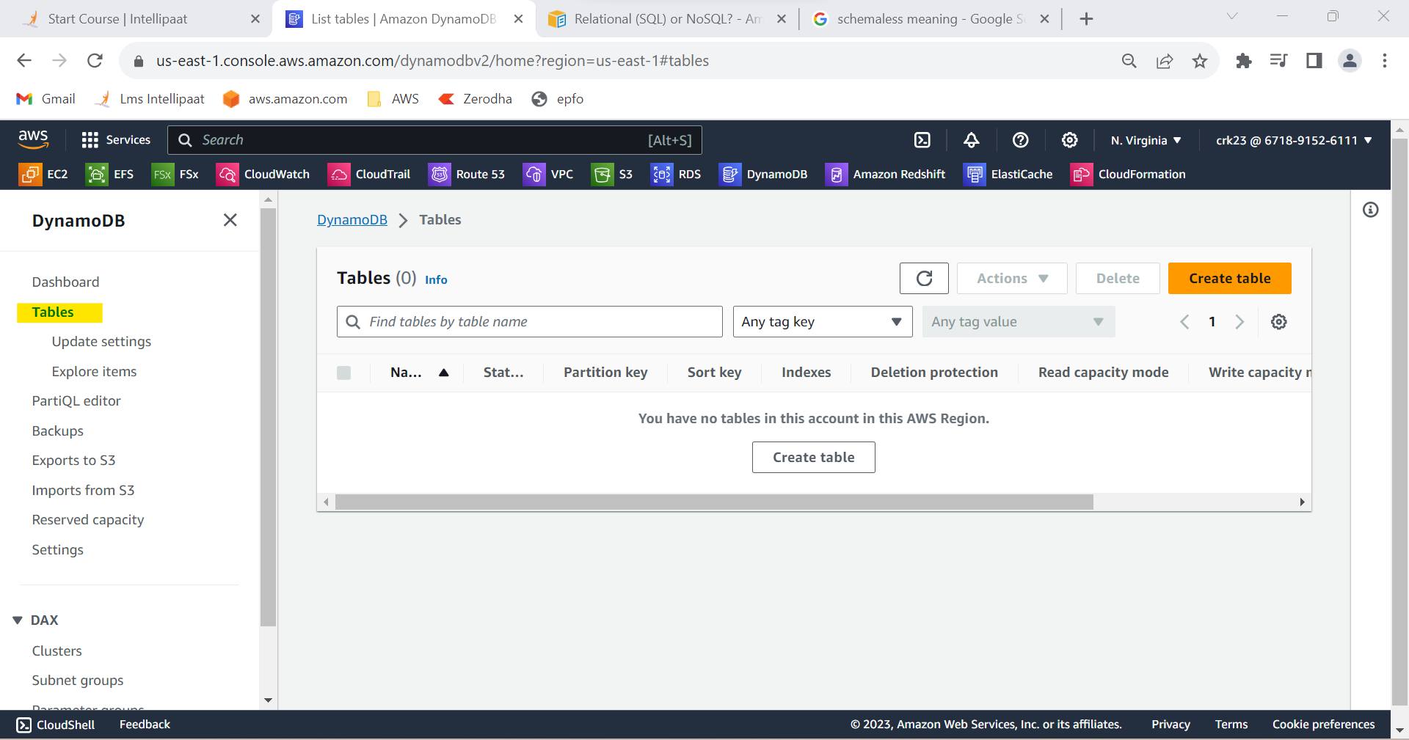

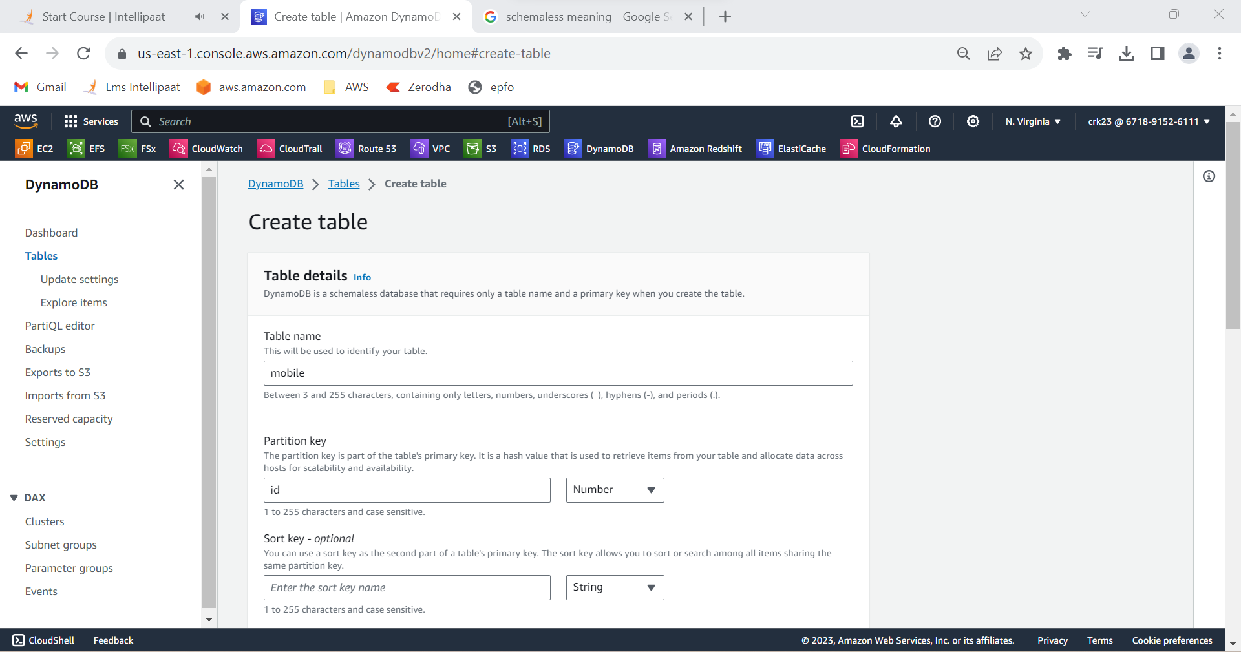

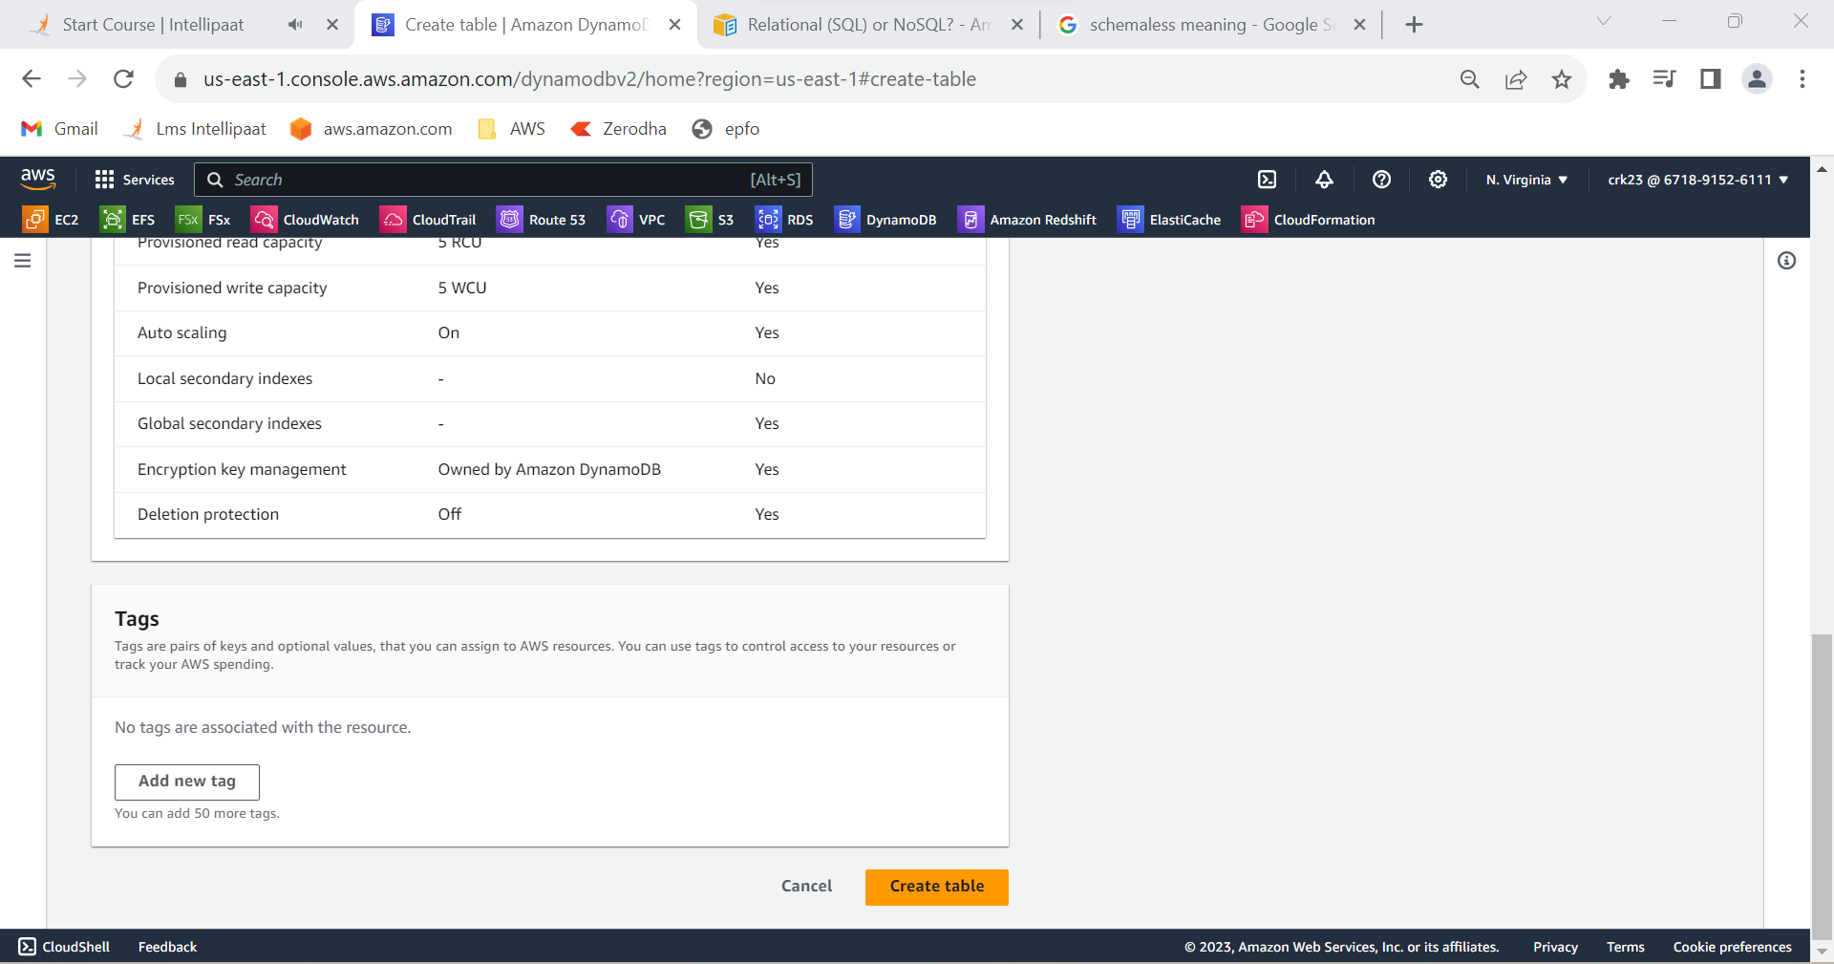

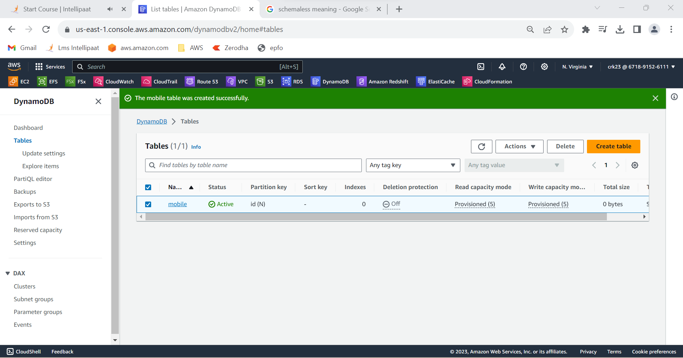

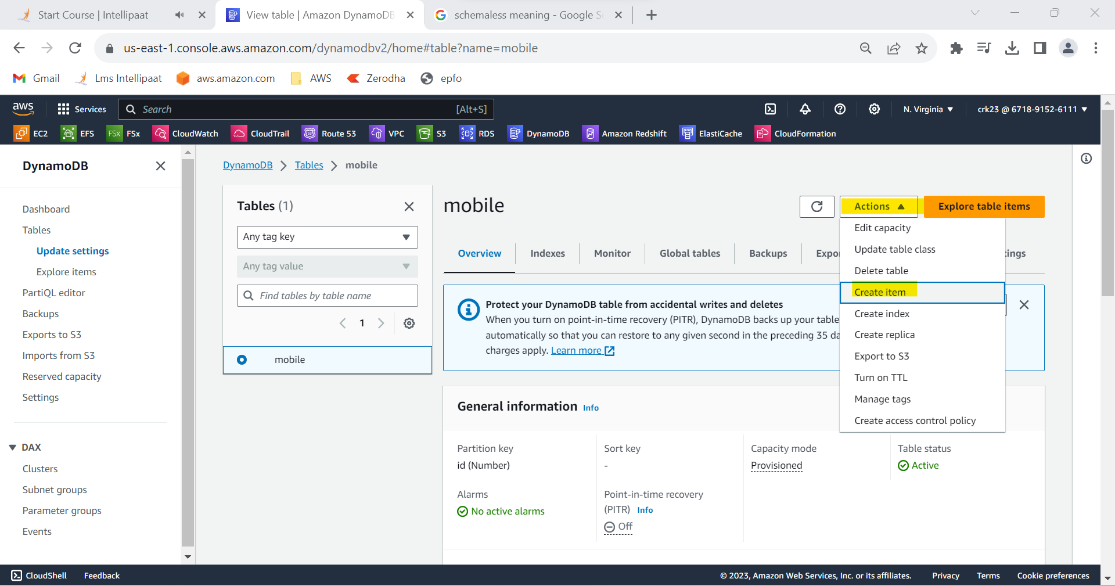

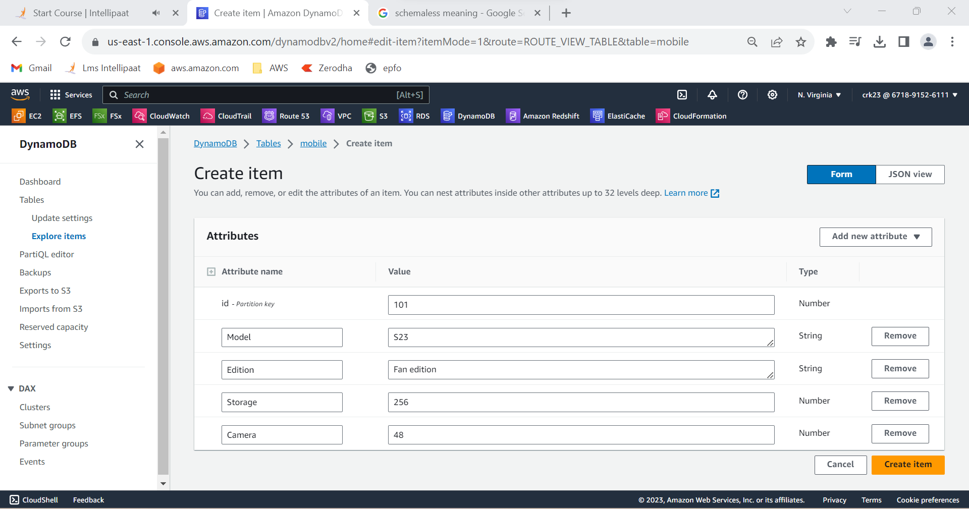

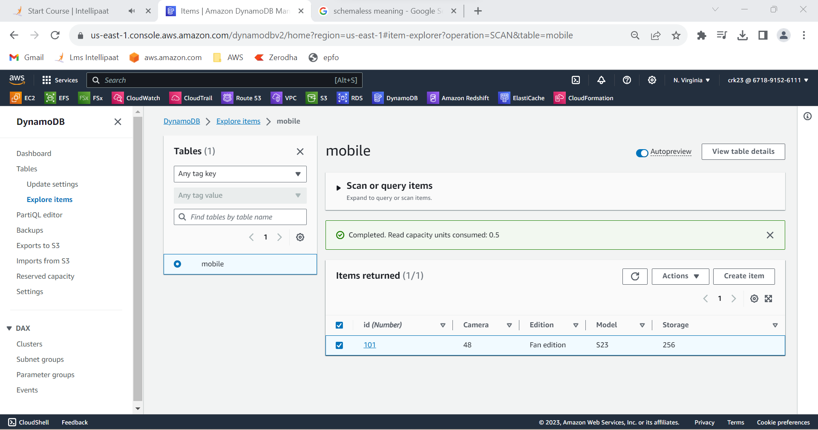

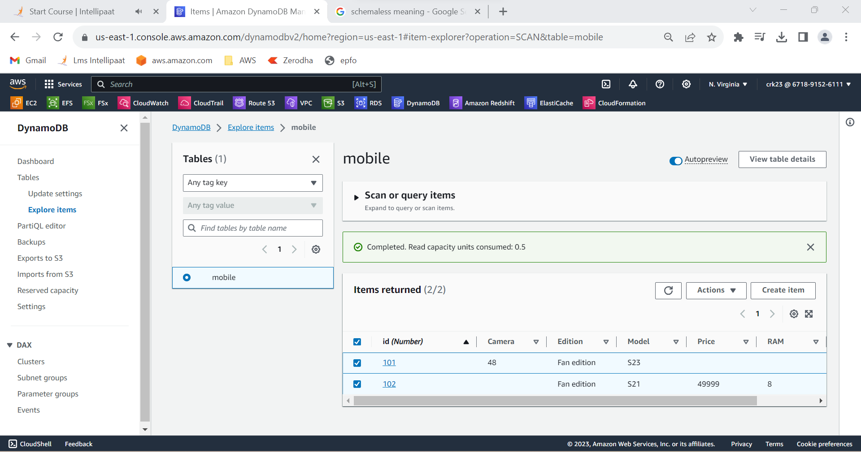

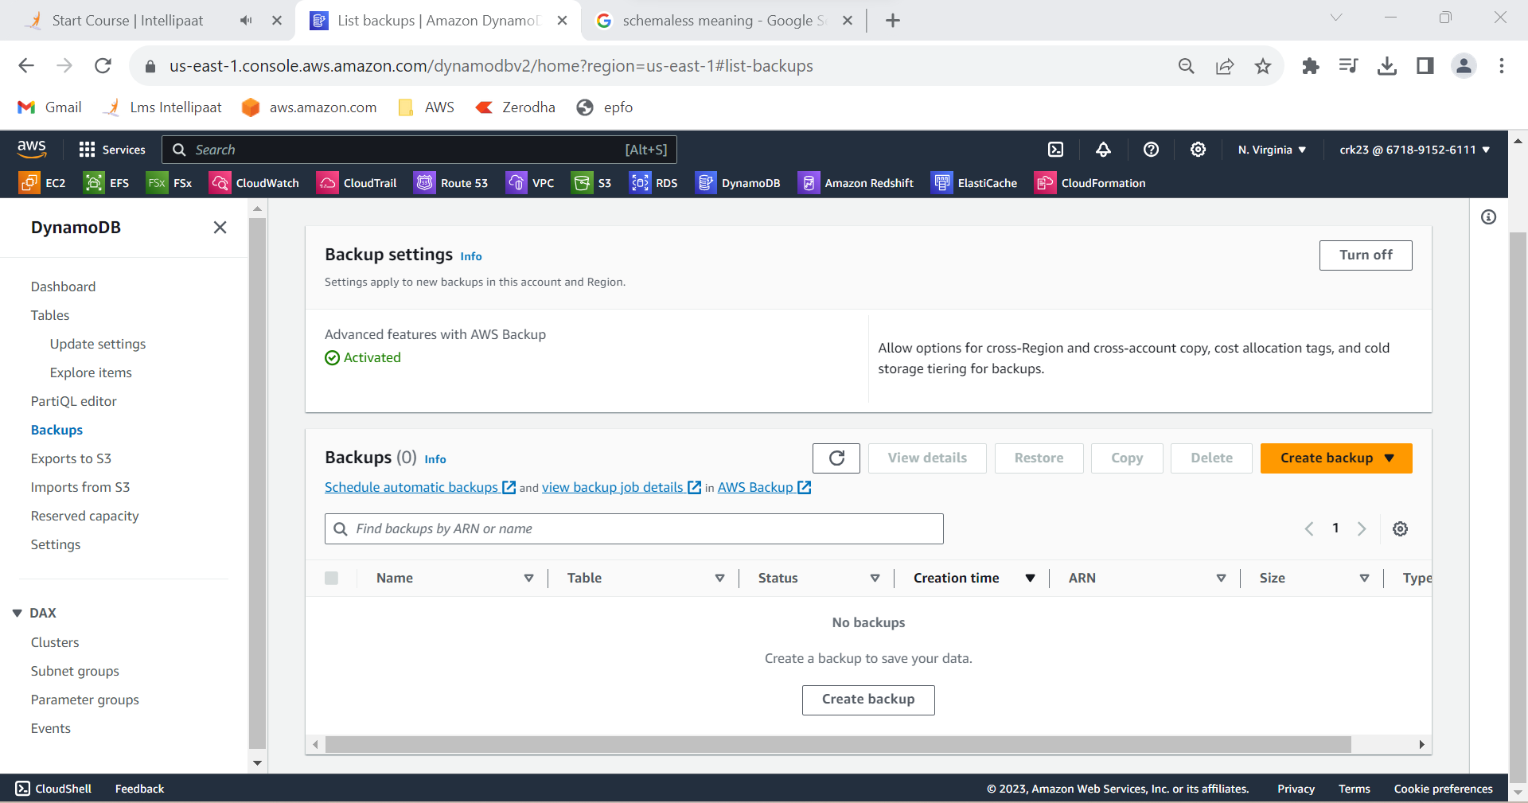

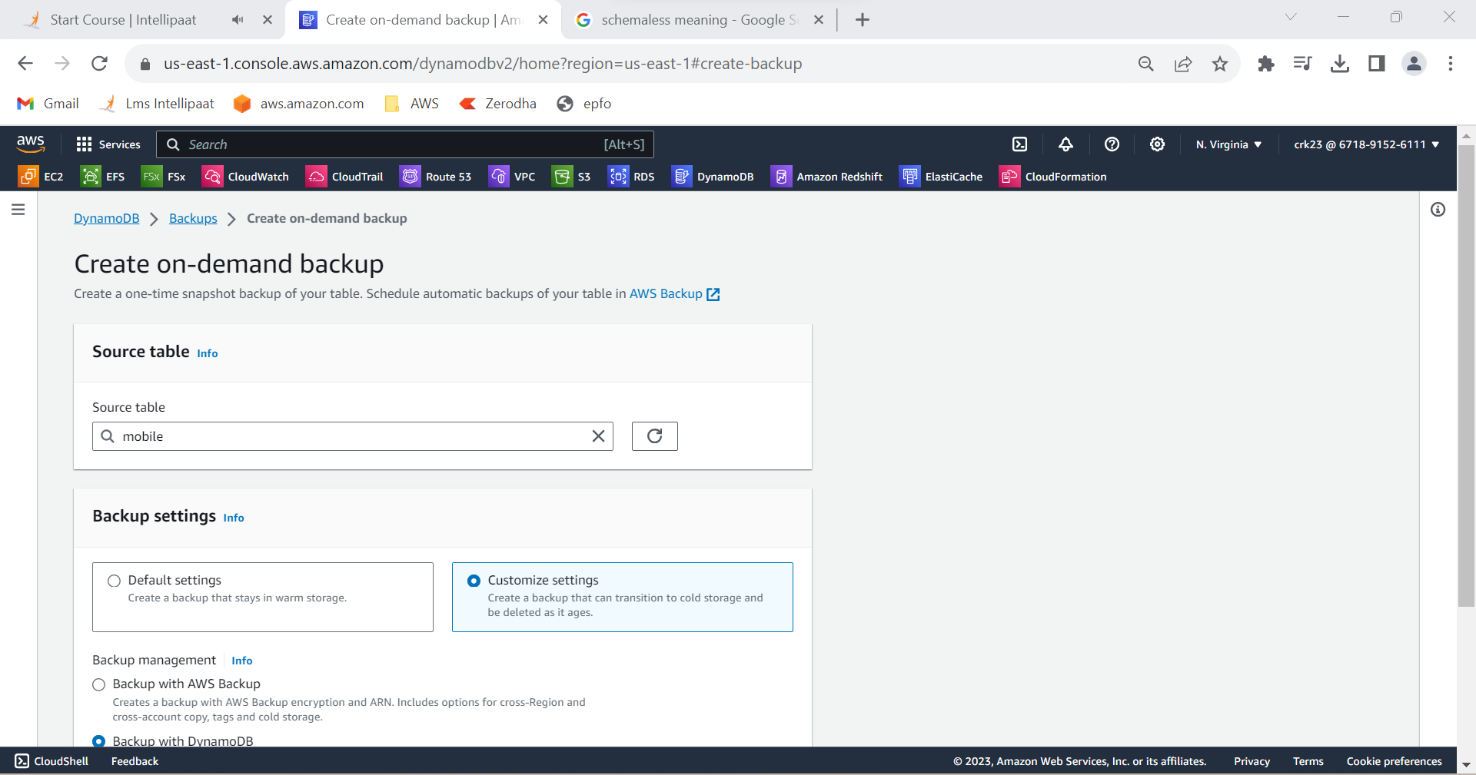

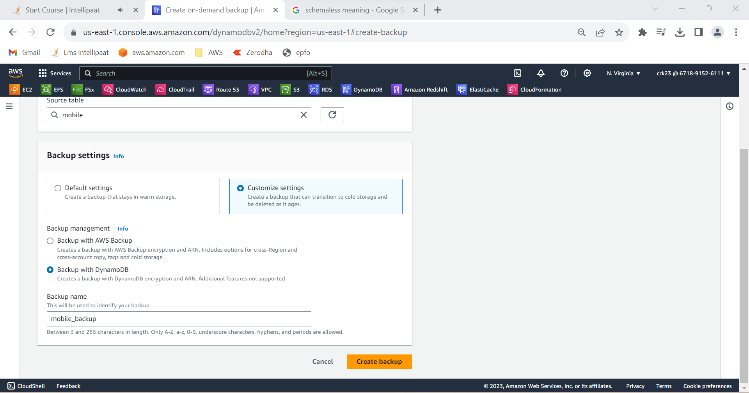

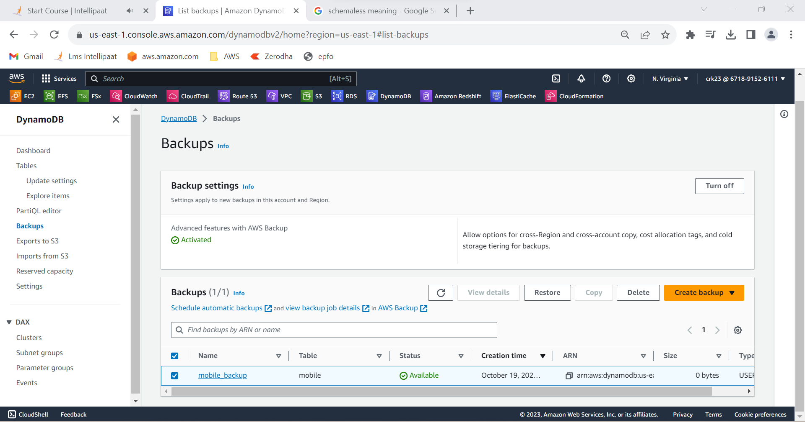

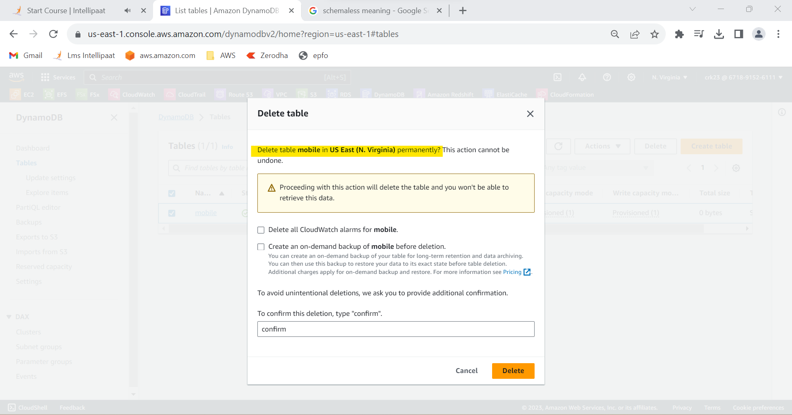

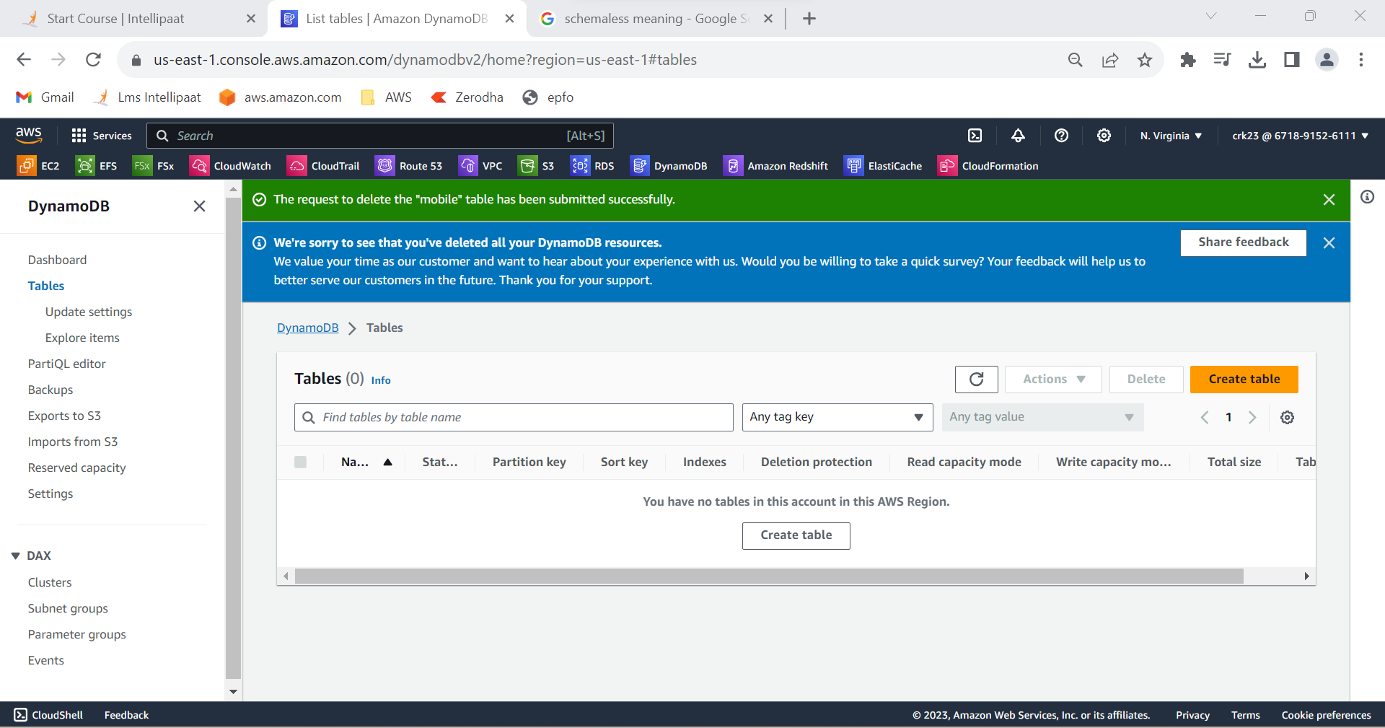

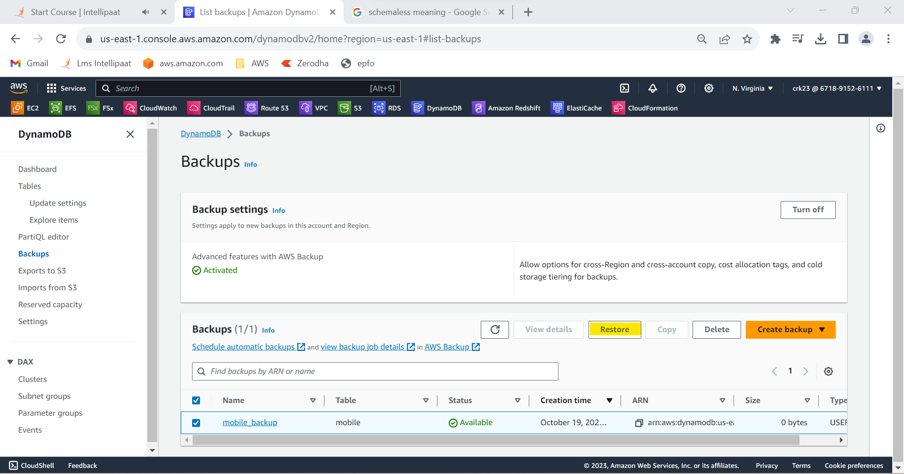

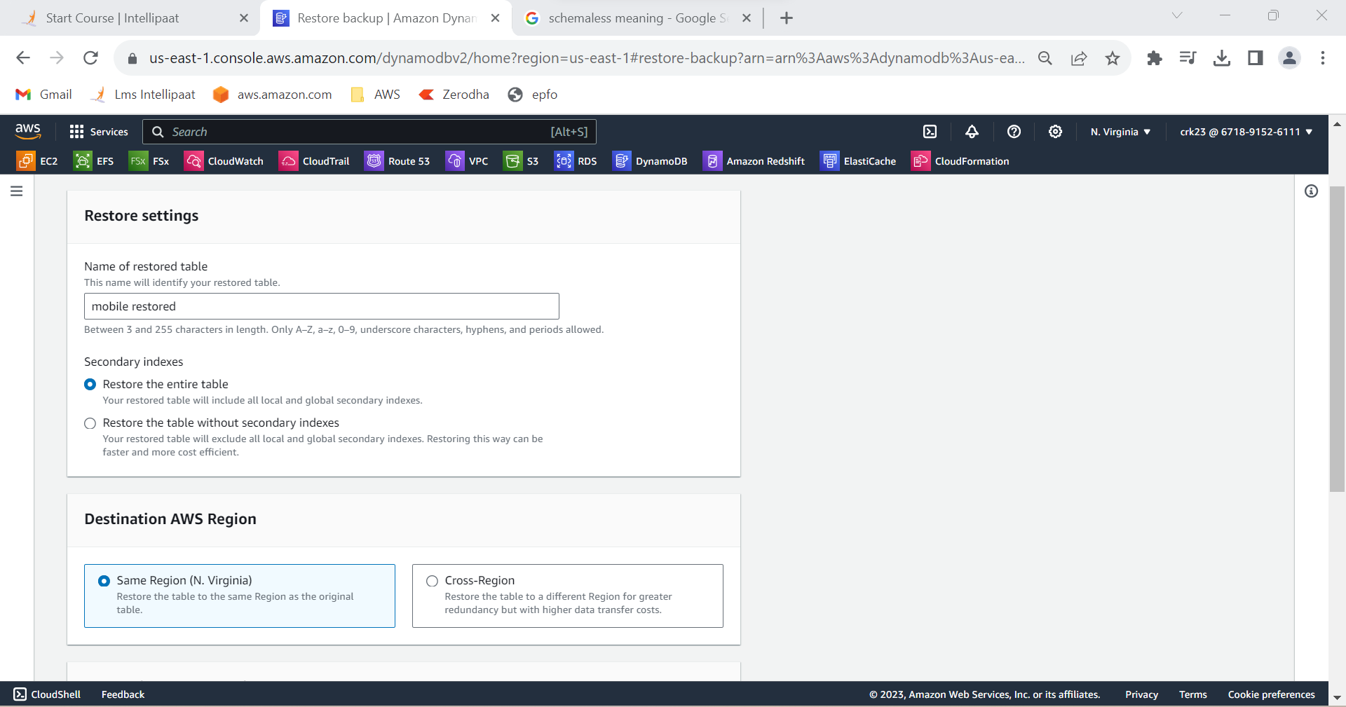

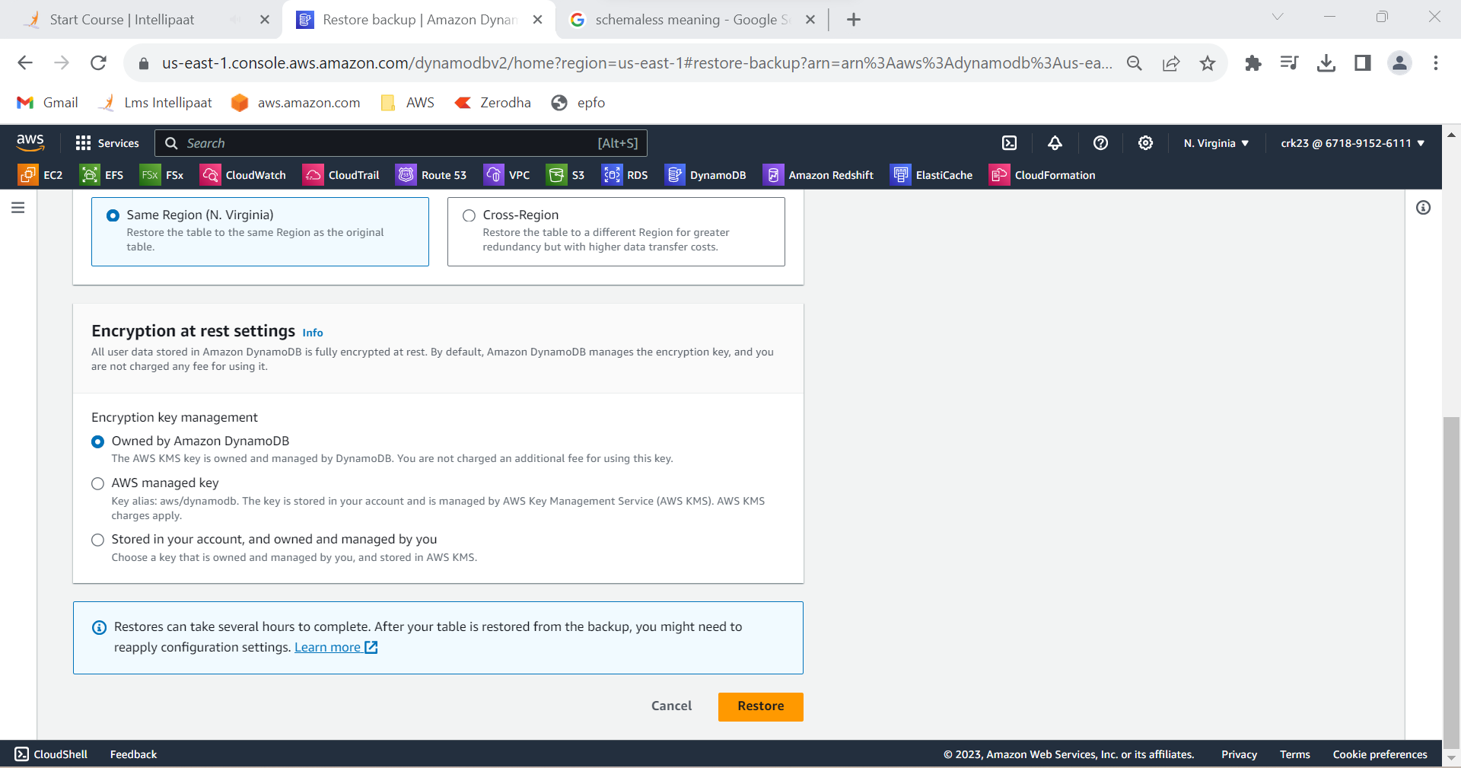

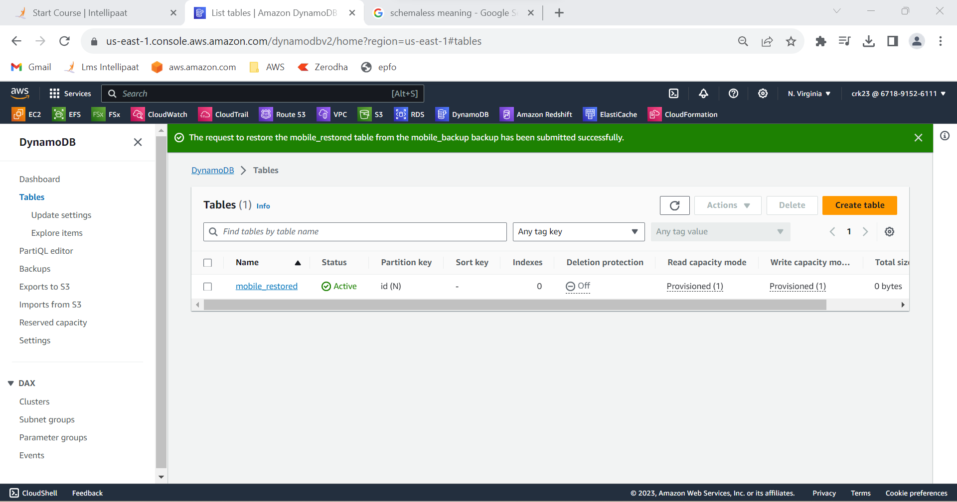

**OUTPUT:**

Created a DynamoDB table with partition key as ID and added items to the table and created a backup and deleted the table.